User Manual

Requirement: IOS device(with Bluetooth module), sensor

1. Run ios app on the IOS device.
2. Power on the sensor.
3. The ios device can successfully connect to the sensor after turn on his Bluetooth module.
4. The ios device can successfully read data form sensor:

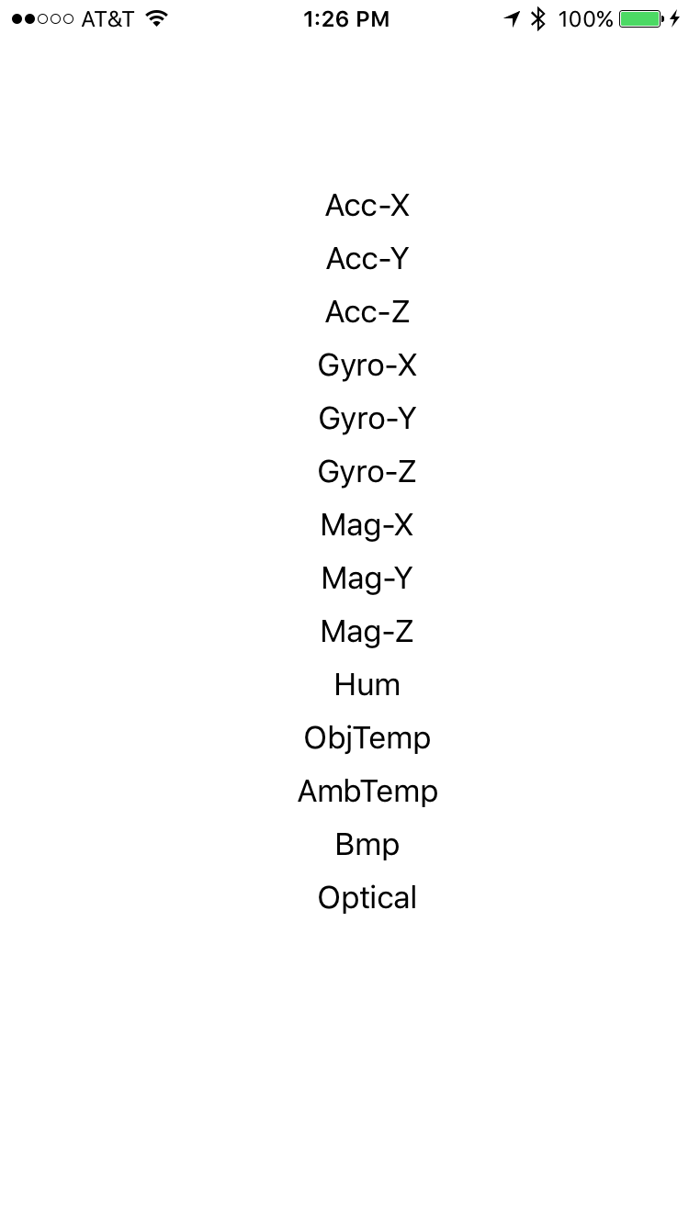

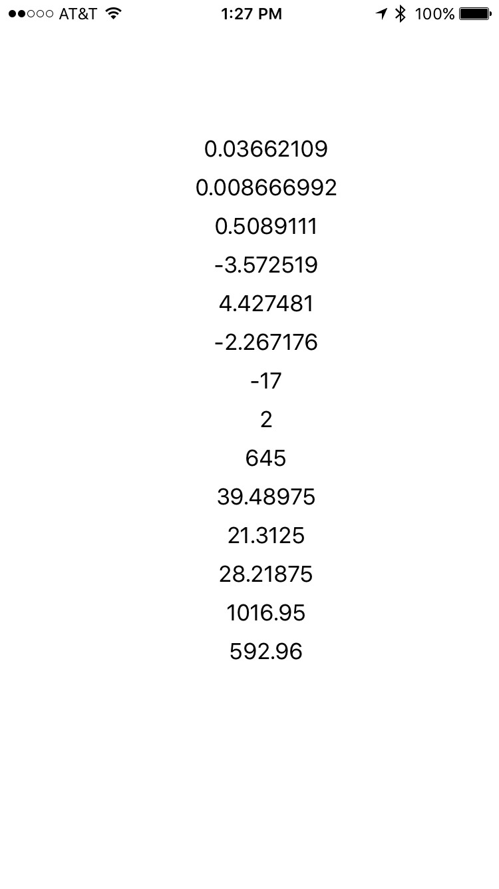

5. The ios app input data into AWS cloud database per 15 seconds.

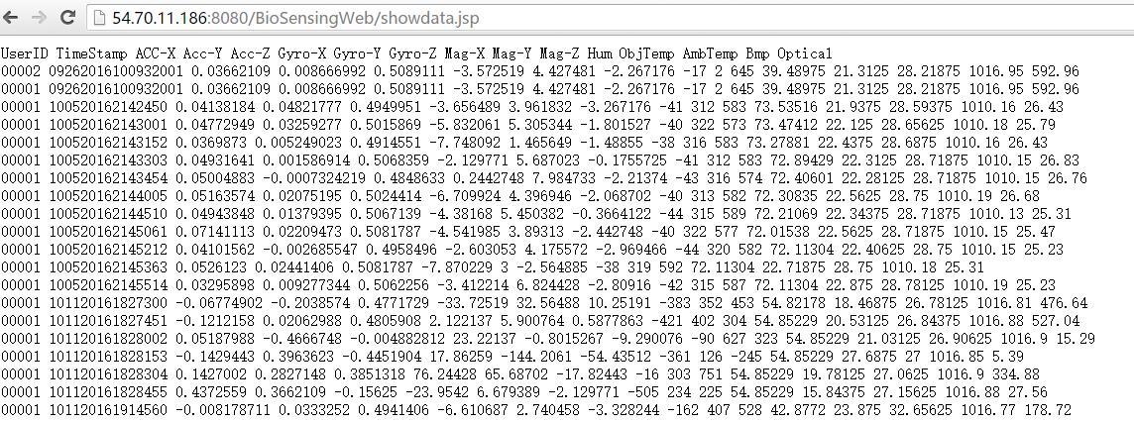

1. After logging, we can see real-time data on the UI:

